**CODES RELATED**

**Product.php codes**

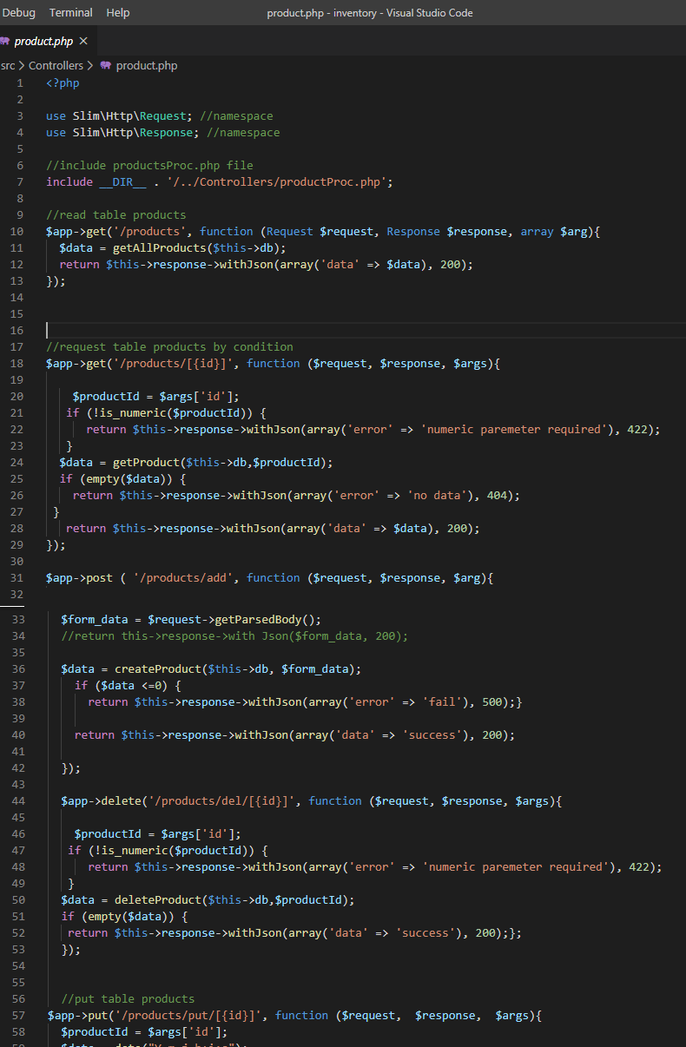

**Figure 1:** This is code for products and its function

This codes above describes about the simple API features that has functions such as delete, edit and post data.

**ProductProc.php codes**

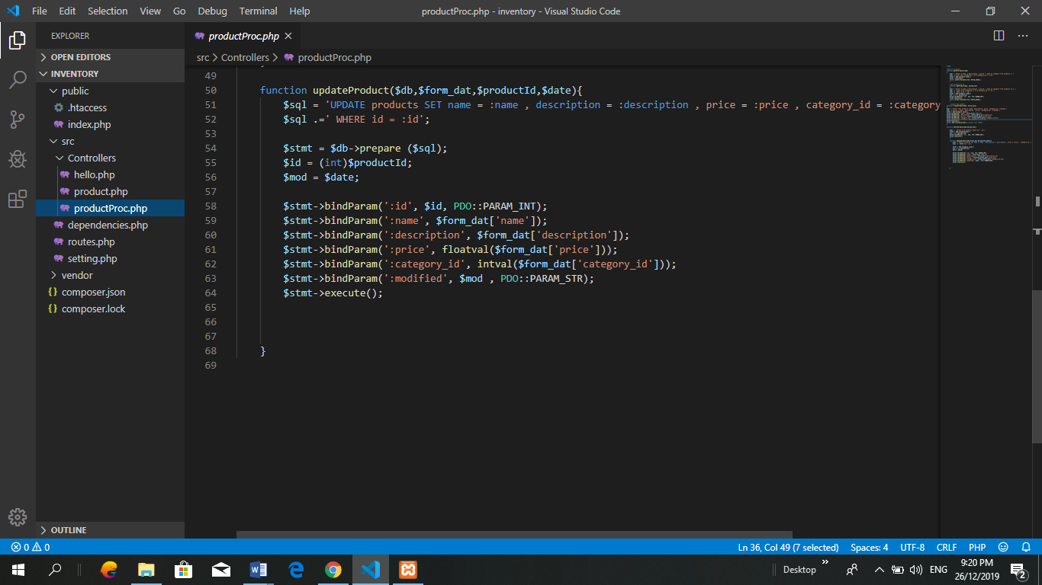

**Figure 2:** This codes includes of database content

This codes shows that every functions such as name, description, price, category and modified is for the database. This will be functions between Talend API and link with database to perform adding data, delete data and edit data through the Talend API that provide by chrome extensions. Talend API is an extension to test which is to perform the functions of the codes API that developer created.

**Response POST**

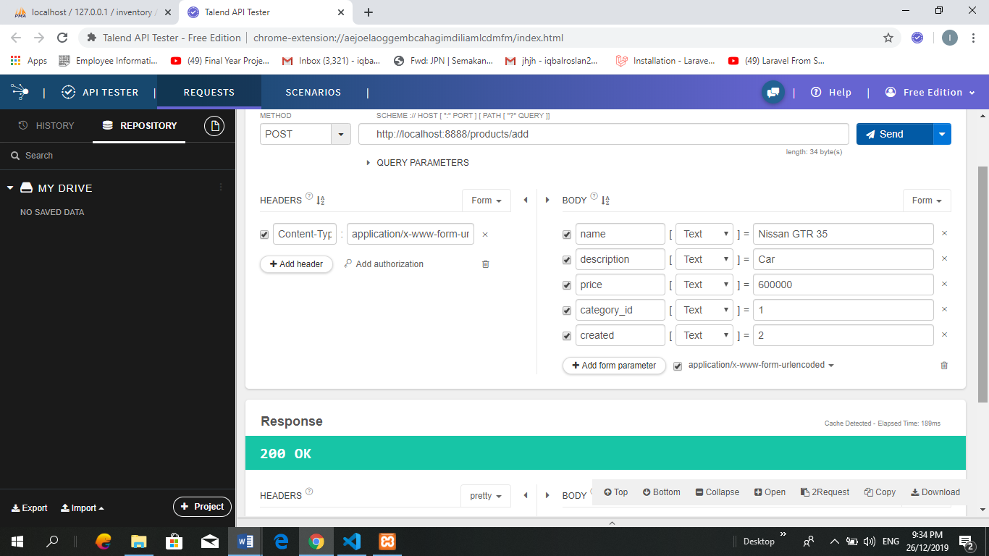

**Figure 3:** POST method

During this phase, developer need to add some information in the form. All the information need to be send first and then will saved into the database. The yellow highlight is for the user to insert data. The red highlight is the method.

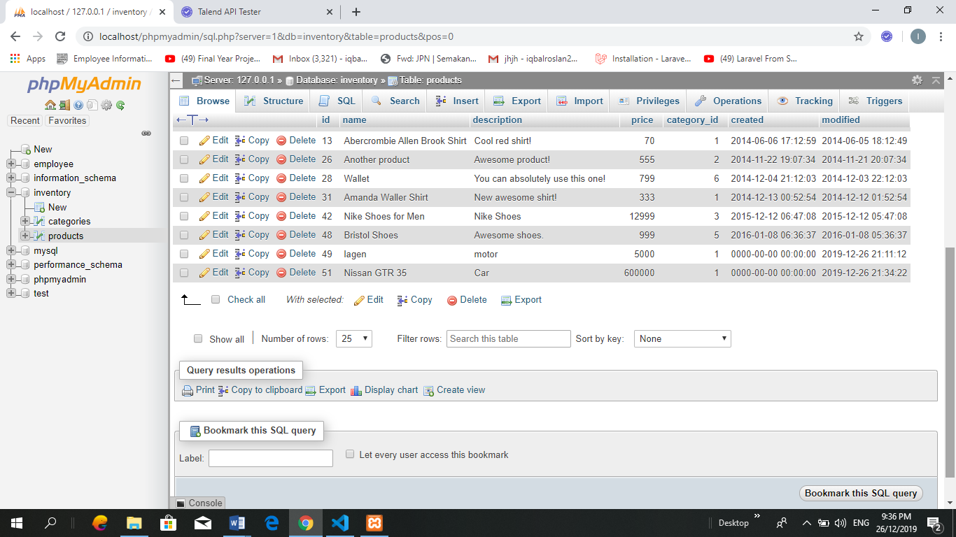

**Figure 4:** Data successfully saved

The data that have been insert in Talend API POST method will be saved in database. The highlight shown that the data successfully saved.

**Response PUT**

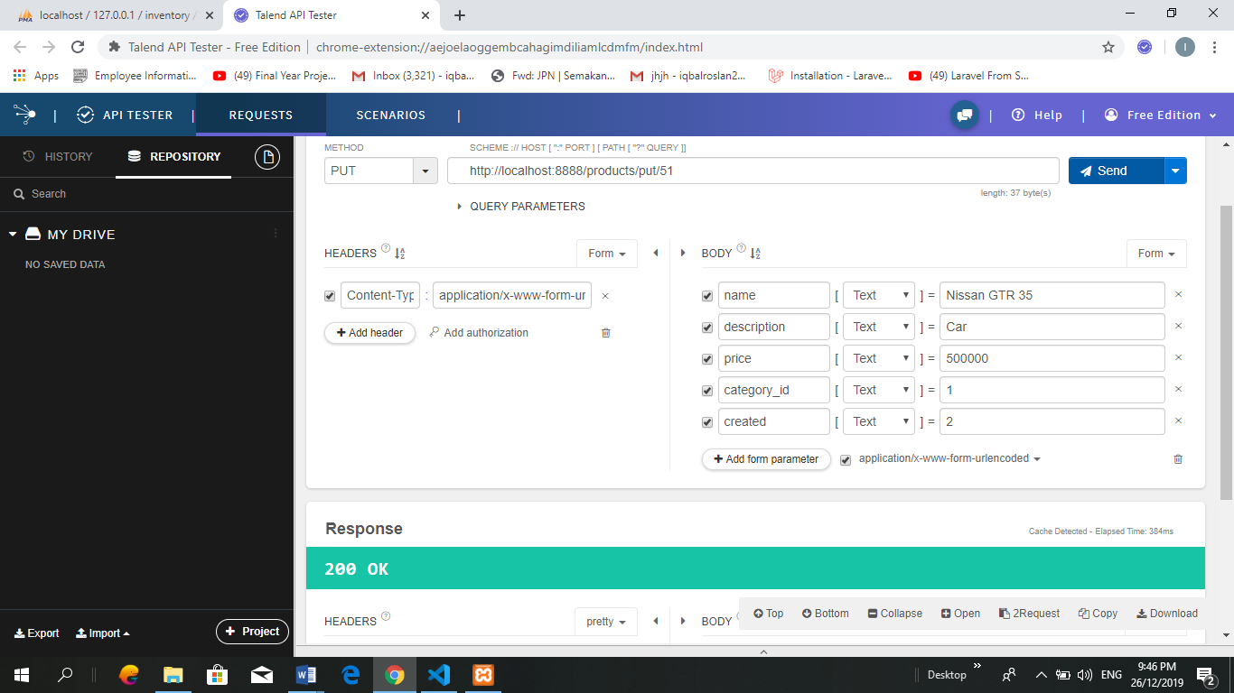

**Figure 5:** PUT method

This phase, developer need to edit information first. After done edited, click send button and then the new edited data will show in database.

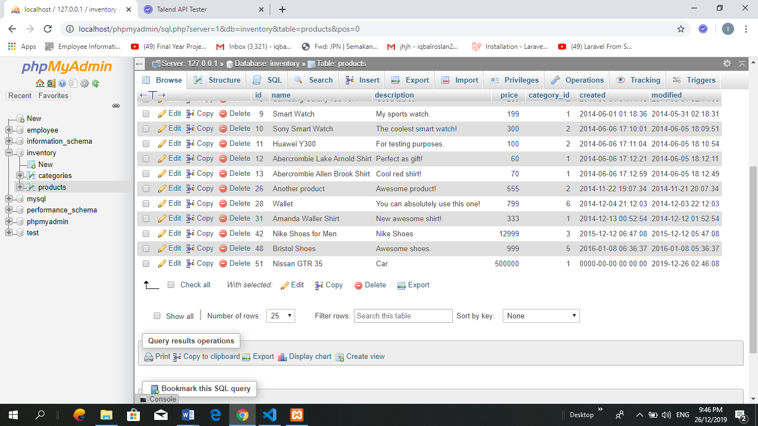

**Figure 6:** Data successfully edited

This highlight in the database shown that the data has been successfully edited

**Response DELETE**

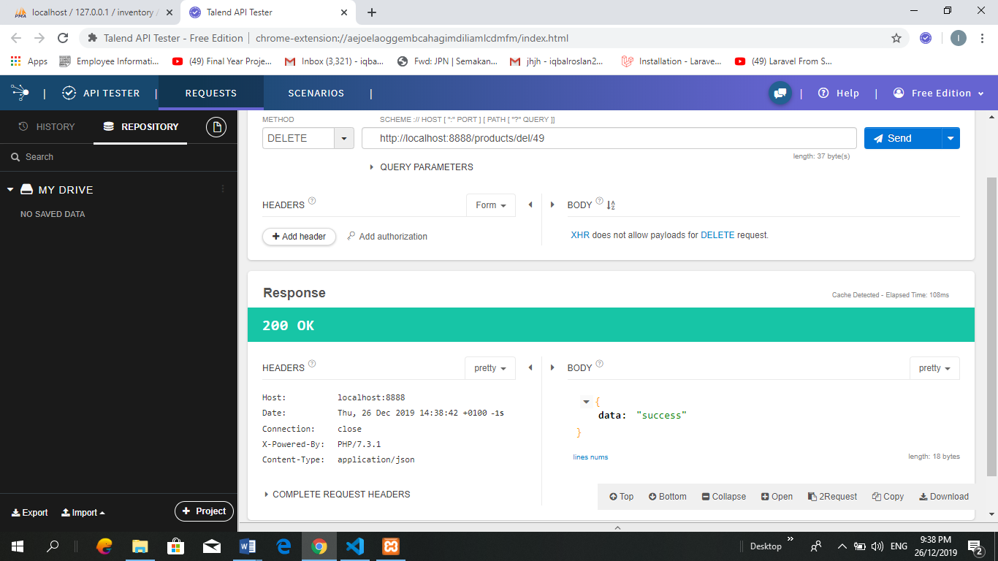

**Figure 7:** DELETE method

This phase for delete method. The red highlight is the method for delete and the yellow highlight developer need to insert the id of the data. After that proceed and send.

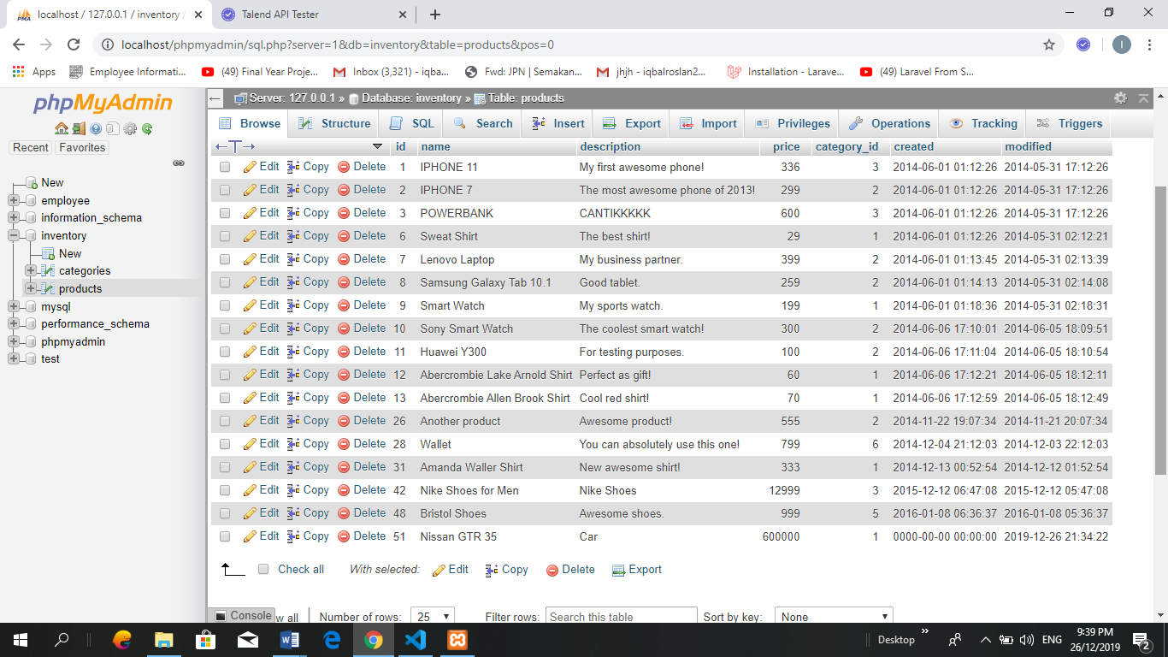

**Figure 8:** Data successfully deleted

The data for id 49 has been successfully deleted.

**Address GitHub**

<https://github.com/AmirulAsyraf96/Create-Simple-API>